

PROJECT REPORT

Real Time Monitoring System

Submitted by: Osayram Fatima

Roll No: BCS-F23-M33

Semester: 5th Regular

Subject: Operating System

Department: Computer Science

Abstract
In today’s digital world, computers run many applications at the same time, which makes system performance monitoring very important. High CPU usage, low memory, heavy disk load, or abnormal network activity can slow down a system and affect user productivity. Most built-in system monitoring tools provide limited features and do not offer clear visual analysis or data export options. This project focuses on developing a Live System Monitoring Dashboard that helps users observe and understand their system’s performance in real time.
The main goal of this project is to design a simple, interactive, and user-friendly monitoring system using Python. The dashboard is developed using Streamlit for the web interface, psutil for collecting system information, and Plotly for creating live graphs. The system continuously tracks important resources such as CPU usage, RAM utilization, disk usage, network input and output speed, battery status, and running processes. All information is displayed on a single web-based dashboard that can be accessed easily through a browser.
The dashboard updates system data at regular intervals and stores recent values to show performance trends over time. Line graphs are used to visualize CPU, memory, disk, and network activity, making it easier for users to identify sudden spikes or unusual behavior. A special feature of the system is CPU core monitoring, where individual core usage is displayed and the most heavily used core is highlighted. This helps in understanding how workload is distributed across the processor. The process monitoring section shows the top running processes based on CPU and memory usage, allowing users to identify resource-intensive applications.
To improve system safety and awareness, the dashboard includes an alert system. Warnings and critical alerts are generated when CPU or RAM usage crosses defined limits. These alerts are stored in a log so that users can review past system stress events. The system also provides an option to export the last five minutes of performance data in CSV format, which can be used for analysis, reporting, or documentation.
In conclusion, the Live System Monitoring Dashboard provides an effective and easy-to-use solution for real-time system performance monitoring. It helps users understand system behavior, detect performance issues early, and manage resources efficiently. The project demonstrates how Python-based tools can be used to build a practical monitoring system suitable for students, developers, and general users.

Introduction
Real-time monitoring has become a core requirement in modern computing environments, where multiple applications, browsers, and services compete for limited CPU, memory, disk, and network resources. When these resources are not observed continuously, systems may experience slowdowns, crashes, and unexpected downtime, often detected only after users complain. Dedicated enterprise monitoring tools exist, but they are usually complex, expensive, or over-engineered for individual users, students, and small labs.
This project focuses on designing a simple yet powerful system monitoring dashboard that runs locally in a browser and provides immediate feedback about system health. Using Python with Streamlit, psutil, and Plotly, the dashboard displays live graphs and metric cards instead of static numbers, making it easier to understand how the machine behaves over time. The application aims to be easy to install, cross-platform, visually appealing, and suitable both for day-to-day usage and for teaching operating-system and performance-analysis concepts.

Literature Review
Several research works and practical implementations highlight the importance of real-time monitoring for maintaining performance and preventing failures. Real-time monitoring is described as a continuous process of collecting and visualizing metrics so that anomalies can be detected instantly, reducing downtime and improving system visibility. Classical tools rely on static thresholds and manual log inspection, which is time-consuming and often reactive rather than proactive. Recent studies propose dashboards and AI-enhanced systems that automatically analyze trends and alert administrators before critical failures occur.
In the Python ecosystem, several examples exist where psutil is combined with web frameworks to build monitoring interfaces. For example, research on web-server monitoring uses Python, psutil, and a web framework to track CPU, memory, and response time in real time through a browser-based dashboard. Other projects demonstrate Windows monitoring dashboards using Streamlit and psutil, showing how Python can deliver professional-grade visualization for CPU, memory, disk, and network metrics with minimal boilerplate code. Compared with these works, the present project focuses on a lightweight, single-host monitor that adds integrated alerts, per-core analysis, process tables, and CSV export while keeping the architecture simple enough for educational use.

Methodology
The proposed system follows a modular architecture with four main layers: data collection, processing, visualization, and alert/export modules. In the data collection layer, the psutil library periodically reads CPU percentage, per-core usage, virtual memory statistics, disk usage, network I/O counters, and information about active processes. These raw values are appended into fixed-length deques, which form a sliding time window and prevent unbounded memory growth while still keeping enough points for smooth graphs.
In the visualization layer, Streamlit serves as the web front-end, and Plotly is used to render interactive line charts for CPU/RAM/disk usage, network throughput, and per-core performance over time. Metric cards display current values, whereas a styled process table shows the top processes sorted by CPU or RAM usage. A separate alert module checks each new reading against defined thresholds and records any warning or critical events in an alert log that is visible to the user. Finally, a data-export component converts recent history into a Pandas DataFrame and generates a downloadable CSV file so that users can perform external analysis or include the results in reports.

HOME PAGE
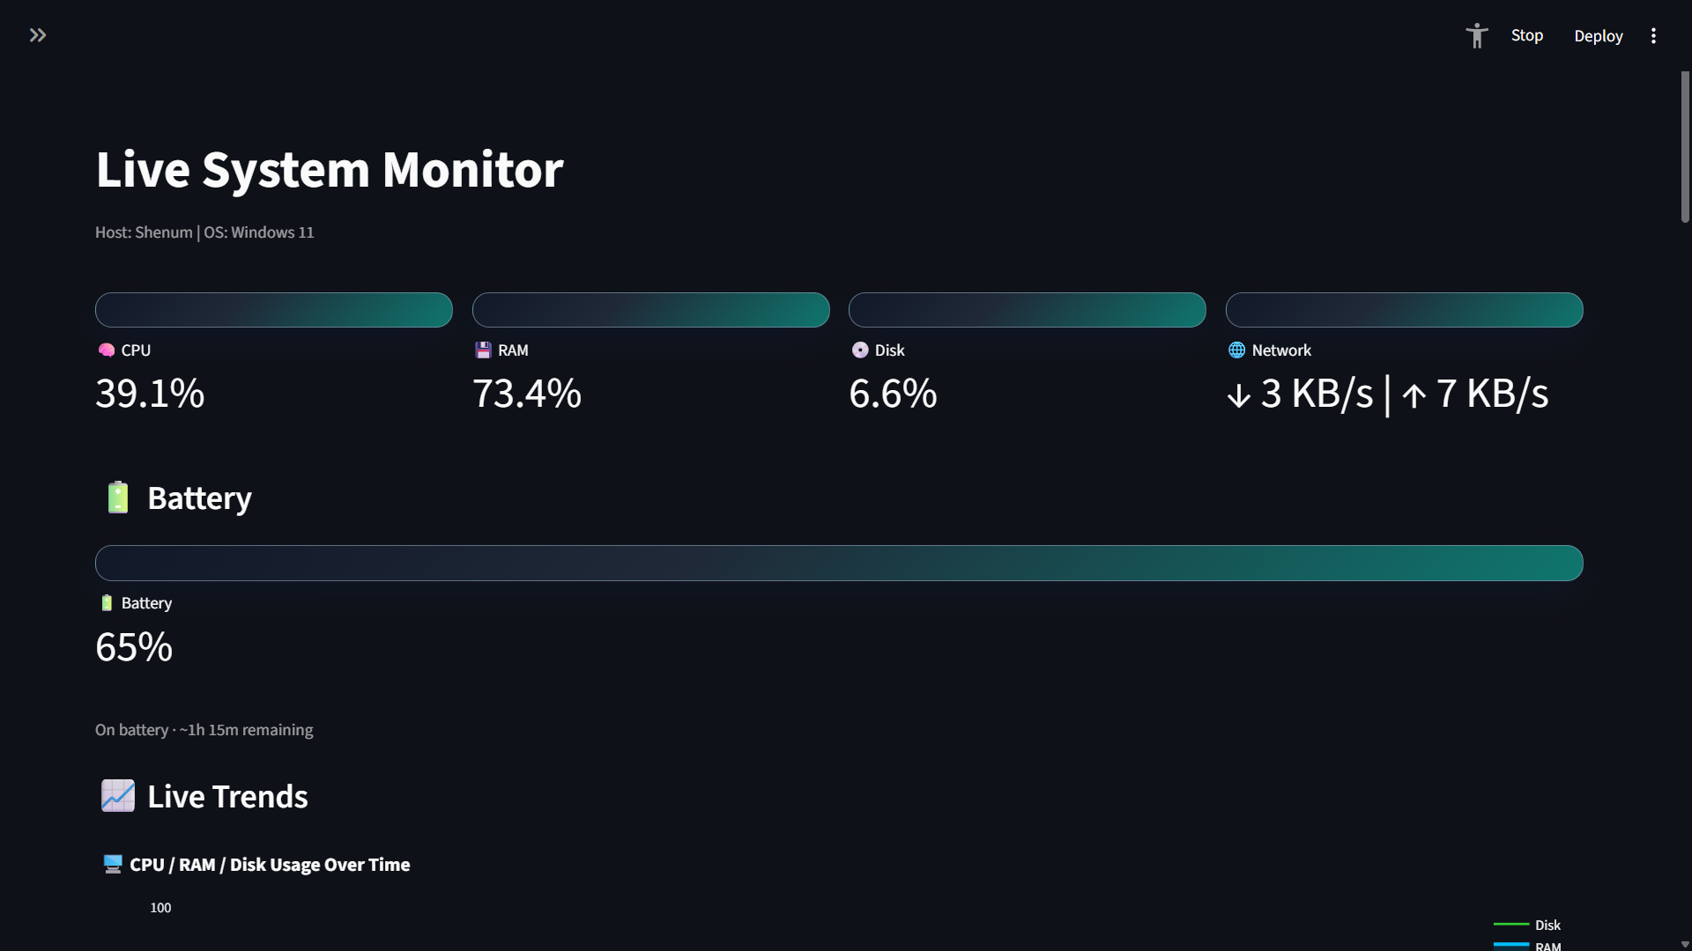
GRAPHS OF CPU,RAM AND NETWORK USAGE
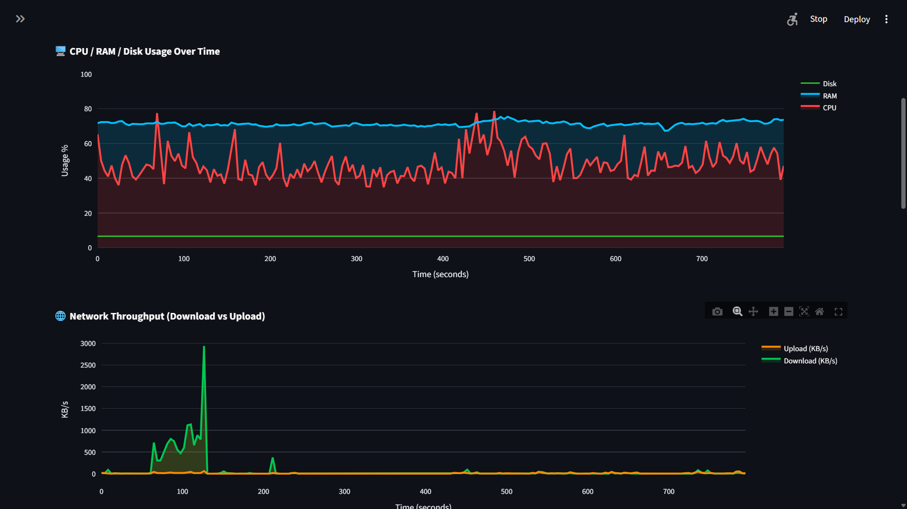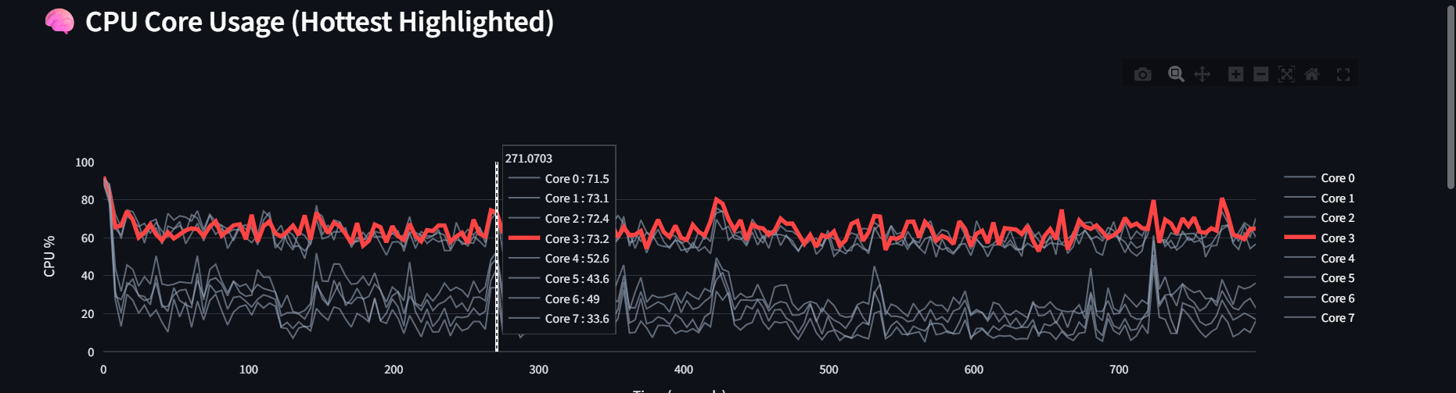
ALTER LOG AND SYSTEM CONTROL
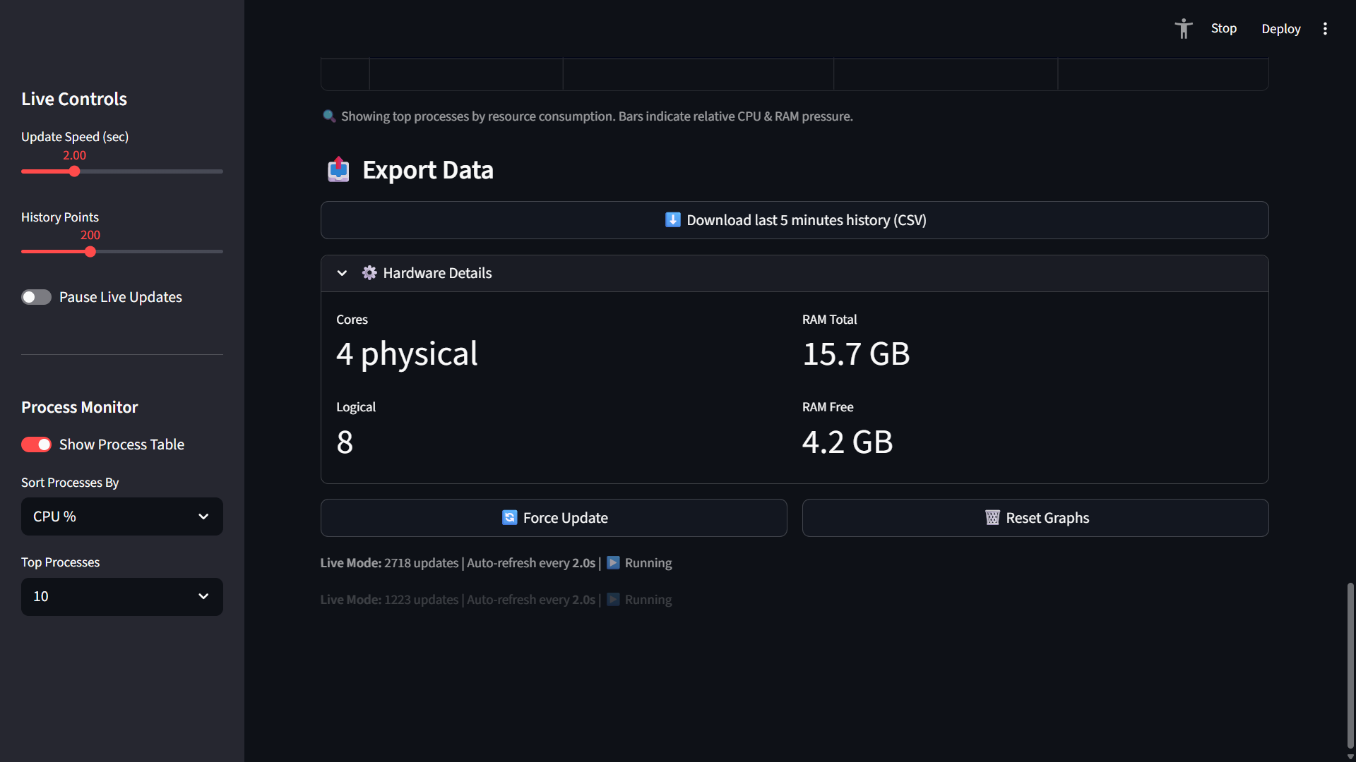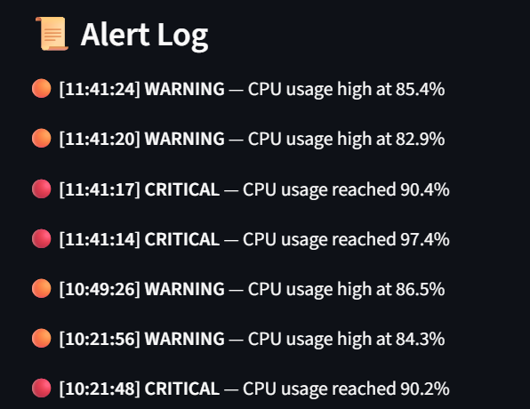
Problem Solving
This project gives normal users and students a simple way to see their system activity in real time through clear graphs and alerts. Instead of confusing raw logs, it shows CPU, RAM, process, and network usage in an easy visual dashboard, with warnings when limits are crossed. Users can also export a short recent window to CSV for extra analysis or comparison.

Data Analysis
The system continuously analyzes real-time performance data and identifies trends:
- CPU Trends: Detects spikes caused by intensive processes
- RAM Usage: Highlights memory leaks or heavy applications
- Disk Usage: Indicates storage pressure
- Network Throughput: Monitors download/upload activity
- Process Table: Identifies resource-hungry processes
Interactive graphs allow users to:
- Compare multiple metrics simultaneously
- Detect performance bottlenecks
- Analyze workload distribution across CPU cores
The alert logs provide historical evidence of system stress events.

Conclusion
This project demonstrates that a real-time system monitoring dashboard can be built efficiently using Python and modern open-source libraries. By leveraging psutil for low-overhead metric collection and Streamlit plus Plotly for visualization, the application delivers a smooth, browser-based experience without the complexity of traditional monitoring suites. The dashboard gives users immediate insight into CPU, memory, disk, network, and process behaviour, and its alert mechanism helps detect performance issues before they become critical.
Beyond practical monitoring, the system has strong educational value: it links operating-system concepts like processes, resource utilization, and scheduling with live, visual feedback that students can experiment with in real time. Future enhancements could include remote-host support, long-term storage with databases, AI-based anomaly detection, or integration with notification channels such as email or messaging apps, but even in its current form the project provides a clear, effective solution for real-time monitoring on a single machine.

References
- Python Software Foundation. Python Documentation.
- Rodola, G. psutil: Cross-platform system monitoring library for Python.
- Streamlit Inc. Streamlit Documentation.
- Plotly Technologies Inc. Plotly Python Graphing Library Documentation.
- Tanenbaum, A. S. Modern Operating Systems. Pearson Education.
- McKinney, W. Python for Data Analysis. O’Reilly Media.

ENDING

